Pete Aguirre II

September 9, 2019

CS 472 - 1002 Senior Design

_____________________________________________________________________________

A.) Use the git log command to output a report showing all commits by author

Mike McQuaid during August 2017 in this format: author name (author date)

and commit message. Chapter 2.3 in the Git Book has instructions and options

you can use for formatting and filtering log output.

Git command used:

git log --author="Mike McQuaid" --since="2017-08-01" --before="2017-09-01" --pretty=format:"%an (%ad) %s"

_____________________________________________________________________________

B.) Rank the activity of the top 10 most active authors by number of commits

during 2016.

Git command used:

git log --date=local --pretty="%h, %an, %ar : %s" --since="2016-01-01" --before="2016-12-31" > ~/gitlog.csv

Explanation:

Prettify git log, isolate dates from 01/01/2016 to 12/31/2016 and download them

all to a CSV file. Edit CSV file on Google Drive (easier to isolate unique

values here), isolate unique names, count their appearances, and voala. Here is

your top 10 most active authors in 2016:

Name: Commits:

Mike McQuaid 1152

Markus Reiter 298

Xu Cheng 234

Martin Afanasjew 219

Dominyk Tiller 210

Alyssa Ross 109

ilovezfs 79

Josh Hagins 72

Baptiste Fontaine 64

Misty De Meo 63

OR (Lazy Way)

git shortlog -sn --since="2016-01-01" --before="2016-12-31"

_____________________________________________________________________________

C.) Report on the total number of commits made each year since the repository

started in 2009.

Git commands used:

(2009) - 610 commits

git log --date=local --pretty="%h, %an, %ar : %s" --since="2009-01-01" --before="2009-12-31" > ~/brewlog2009.csv

(2010) - 540 commits

git log --date=local --pretty="%h, %an, %ar : %s" --since="2010-01-01" --before="2010-12-31" > ~/brewlog2010.csv

(2011) - 555 commits

git log --date=local --pretty="%h, %an, %ar : %s" --since="2011-01-01" --before="2011-12-31" > ~/brewlog2011.csv

(2012) - 1170 commits

git log --date=local --pretty="%h, %an, %ar : %s" --since="2012-01-01" --before="2012-12-31" > ~/brewlog2012.csv

(2013) - 1886 commits

git log --date=local --pretty="%h, %an, %ar : %s" --since="2013-01-01" --before="2013-12-31" > ~/brewlog2013.csv

(2014) - 2068 commits

git log --date=local --pretty="%h, %an, %ar : %s" --since="2014-01-01" --before="2014-12-31" > ~/brewlog2014.csv

(2015) - 1770 commits

git log --date=local --pretty="%h, %an, %ar : %s" --since="2015-01-01" --before="2015-12-31" > ~/brewlog2015.csv

(2016) - 3066 commits

git log --date=local --pretty="%h, %an, %ar : %s" --since="2016-01-01" --before="2016-12-31" > ~/brewlog2016.csv

(2017) - 3075 commits

git log --date=local --pretty="%h, %an, %ar : %s" --since="2017-01-01" --before="2017-12-31" > ~/brewlog2017.csv

(2018) - 2800 commits

git log --date=local --pretty="%h, %an, %ar : %s" --since="2018-01-01" --before="2018-12-31" > ~/brewlog2018.csv

(2019) - 1432 commits

git log --date=local --pretty="%h, %an, %ar : %s" --since="2019-01-01" --before="2019-12-31" > ~/brewlog2019.csv

And then, last line should be number of commits that has been made

OR (Lazy way)

(2009) - 610 commits

git rev-list --count HEAD --since="2009-01-01" --before="2009-12-31"

(2010) - 540 commits

git rev-list --count HEAD --since="2010-01-01" --before="2010-12-31"

(2011) - 555 commits

git rev-list --count HEAD --since="2011-01-01" --before="2011-12-31"

(2012) - 1170 commits

git rev-list --count HEAD --since="2012-01-01" --before="2012-12-31"

(2013) - 1886 commits

git rev-list --count HEAD --since="2013-01-01" --before="2013-12-31"

(2014) - 2068 commits

git rev-list --count HEAD --since="2014-01-01" --before="2014-12-31"

(2015) - 1770 commits

git rev-list --count HEAD --since="2015-01-01" --before="2015-12-31"

(2016) - 3066 commits

git rev-list --count HEAD --since="2016-01-01" --before="2016-12-31"

(2017) - 3075 commits

git rev-list --count HEAD --since="2017-01-01" --before="2017-12-31"

(2018) - 2800 commits

git rev-list --count HEAD --since="2018-01-01" --before="2018-12-31"

(2019) - 1432 commits

git rev-list --count HEAD --since="2019-01-01" --before="2019-12-31"

IF merges should not be included, add an extention: --all --no-merges

i.e. git rev-list --count HEAD --since="2009-01-01" --before="2009-12-31" --all --no-merges

_____________________________________________________________________________

D.) Generate a list of the top 10 contributors (authors-the most # lines of

code) to the project during the first 6 months of 2017 and identify how many files they modified and how many lines of code they inserted and deleted. Rank them based on number of insertions. (Hint: use the --shortstat option to get the raw data). Run the same report for calendar year 2016. Explain briefly how you compiled the list.

Git command used:

(2017)

git log --since="2017-01-01" --before="2017-06-30" --pretty="@%h," --shortstat | tr "\n" " " | tr "@" "\n" > ~/stats.csv

git log --pretty="%an" --since="2017-01-01" --before="2017-06-30" > ~/names.csv

Top 10 Contributors (Based on Insertion):

Name: Insertions:

Markus Reiter 20823

Mike McQuaid 7173

Gautham Goli 3006

William Woodruff 2206

EricFromCanada 1172

Alyssa Ross 839

Bob W. Hogg 384

Ilovezfs 375

Misty De Meo 315

Joshua McKinney 304

Explanation:

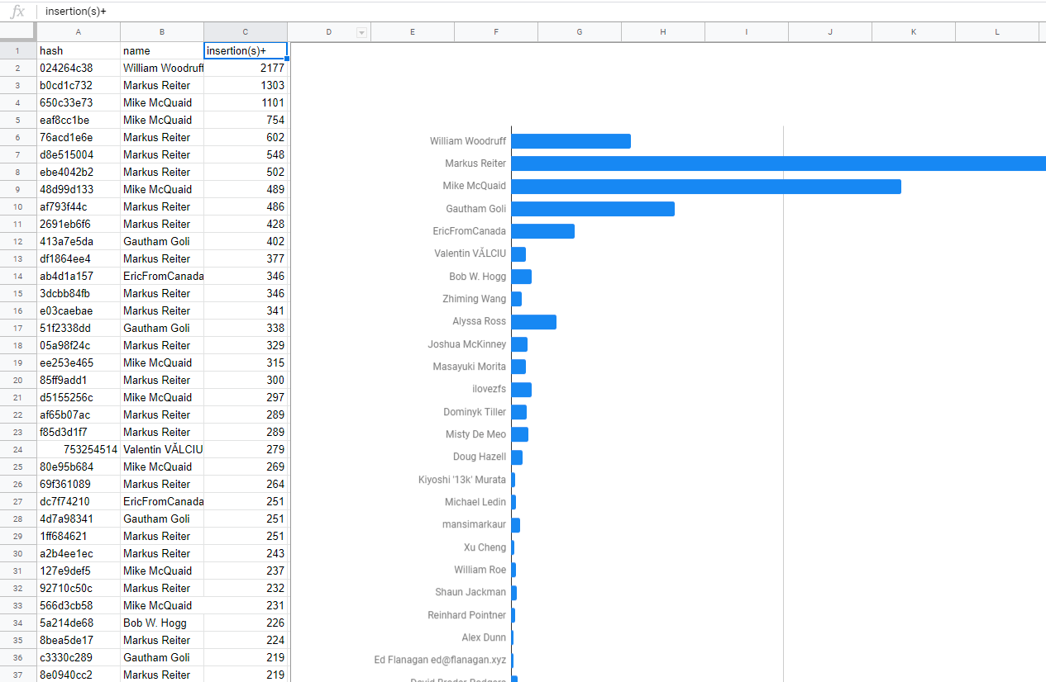

A graph that aggregates all the name values and sums the amount of insertions. Markus Reiter being the obvious winner here and some other obvious outliers, like: Mike, Gautham, William, EricFromCanada, and Alyssa Ross. The other I had to spot manually. A separate graph like this was also done with File Changes and Deletion.

Git command used:

(2016)

git log --since="2016-01-01" --before="2016-12-31" --pretty="@%h," --shortstat | tr "\n" " " | tr "@" "\n" > ~/stats.csv

git log --pretty="%an" --since="2016-01-01" --before="2016-12-31" > ~/names.csv

Top 10 Contributors (Based on Insertion):

Name: Insertions:

AnastasiaSulyagina 22415

Markus Reiter 20197

Mike McQuaid 12118

William Woodruff 4697

Martin Afanasjew 37989

Xu Cheng 3620

Baptiste Fontaine 3374

Alyssa Ross 2207

Andrew Janke 1645

Vlad Shablinsky 1129

Explanation:

Same process as before.

_____________________________________________________________________________